Brightspeed EASE LSR Job Aid
May 2018 Release (v1)

Version notice
History
All versions of this document are listed in reverse chronological order.

Version | Date | Description
1.1 | May 2018 | Final Document
1.0 | March 2018 | Initial Document Creation
Important: This document has been through a formal review process. To the best of our knowledge, it is accurate. Brightspeed Communications, Inc. reserves the right
to make further modifications when necessary.

Table of Contents
Overview 3
LSR Pre-Order 3
EASE Validate CFA (Connecting Facility Assignment) (TXTYP = K) 4
Group Response Cable Facility Query 6
Unit (also known as Channel) Response Cable Facility Query 14
Successful Responses 18
Unsuccessful Responses 19

Overview
The Brightspeed EASE LSR May 2018 Release Job Aid provides information associated to the introduction of new EASE LSR Pre-Order functionality during the second quarter of 2018.

The online EASE Local Service Request VFO Pre-Order Guide will be updated to incorporate the changes and additions identified in this Job Aid prior to the deployment of this functionality.

LSR Pre-Order
A new Pre-Order transaction type is being introduced in EASE LSR:

K= Valdiate CFA (Connecting Facility Assignment)

PreOrder Initiation screen
The new Validate CFA pre-order functionality, TX Type = K, has been added to the existing dropdown.

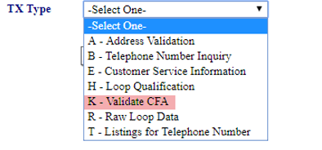

EASE Validate CFA (Connecting Facility Assignment) (TXTYP = K)
CFA is a field on the Loop Service form that identifies the:
- Dedicated transport facility on which the service will ride
- Cable Name (DS0, DS1, DS3 termination)
- Cable and pair the Loop will use to connect the ICDF/SPOT frame that is collocated with Brightspeed
- Slot number
- A to Z CLLI (Common Language Location Identification) codes.

Either before or while preparing an LSR, select one of the available carrier facility assignment (CFA) units for the services being requested by selecting one of the available CFA units from a list of units or channels.

The available CFA units can be found either by specifying the units directly or by searching first for CFA groups and then selecting the units or channels from the groups.

A CFA inquiry can be executed within EASE for Pre-Order.

- Select New from the PREORDER tab.

- A Pre-Order Initiation screen will display. To execute a CFA inquiry, complete the following fields:
  - TXNUM – The system will pre-populate this field with a numeric value.

The user can override this information with the PON to be used during ordering to better track their inquiries.

  - TXTYP – Select K = CFA
  - Select the Initiate button.
- A new CFA Inquiry screen will display.

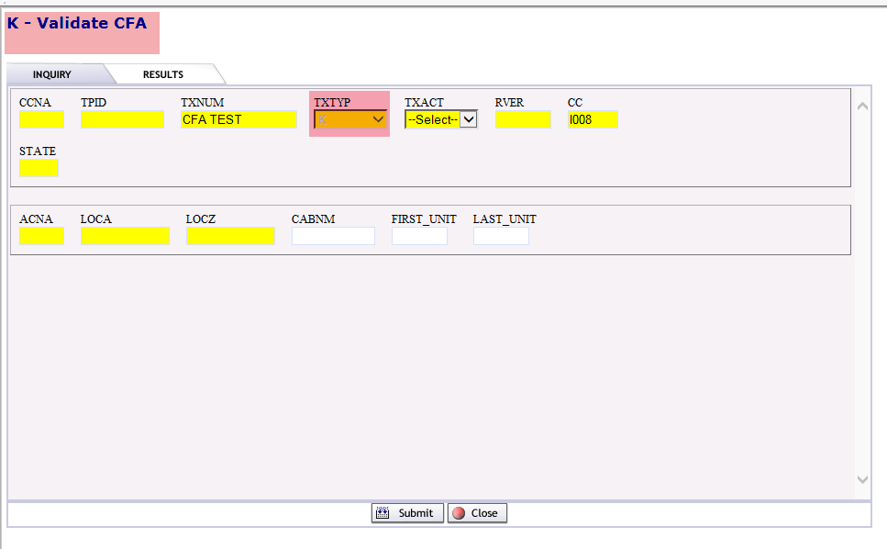

- Complete the following fields.
  - TXACT - Select A = New inquiry.
  - STATE – Enter appropriate 2 digit state code in upper case.

The CFA Pre-Order can support transactions for a basic Cable Facility query that provides:
- CFA Groups
- CFA Units (also known as Channels)

Note: The CFA Query can bypass the Groups detail if the original query includes Unit information.

Group Response Cable Facility Query
If the entire cable facility data is not known, the group detail can be entered first which will provide the unit or channel detail as a secondary part of the query.

- Enter data for a basic Group Response Cable Facility query:
  - ACNA – The Common Language code for your company.
  - LOCA – The originating CLLI code.
  - LOCZ – The terminating CLLI code.

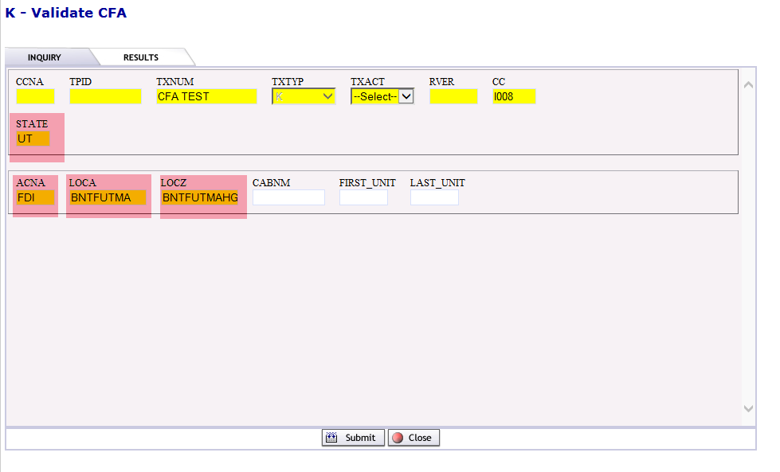

- Select Submit.

- The CFA response provides the following detail:
- CABNM
- CABTYP
- FIRST UNIT (also known as Channel)
- LAST UNIT (also known as Channel)
- LOCA
- LOCZ
- INVSTAT
- QTYSPARE
- PCTAVAIL
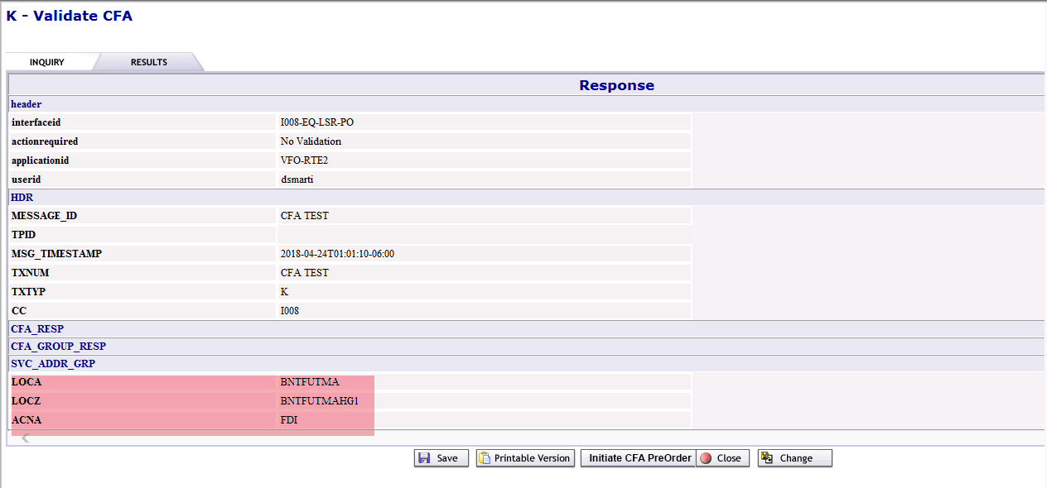

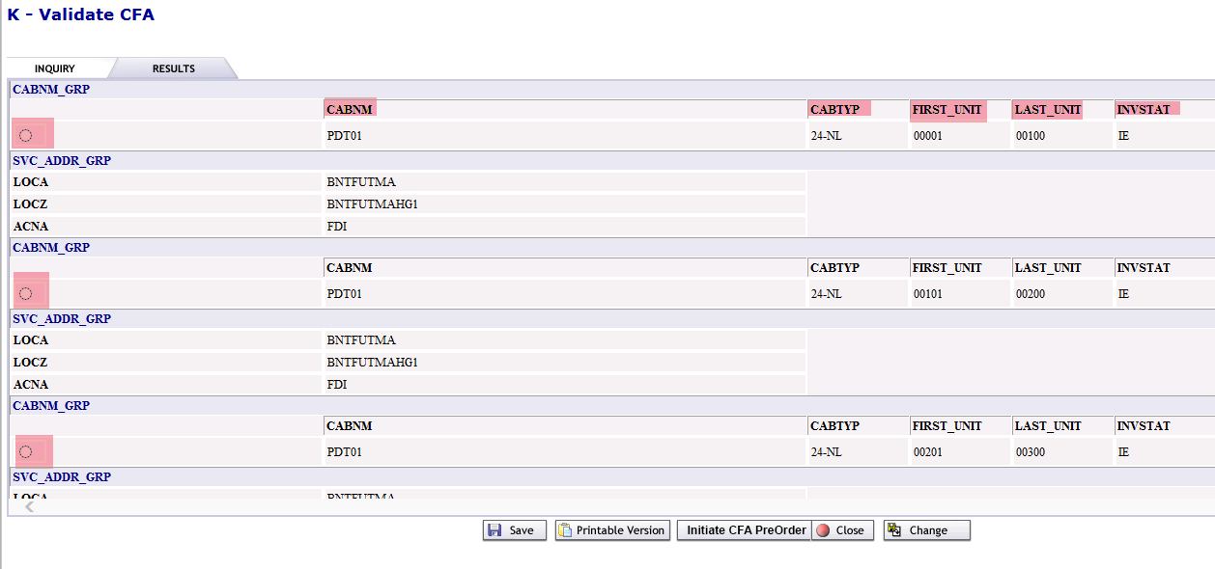

The Results output is extremely wide. Scroll to the right to see the remaining columns of data.

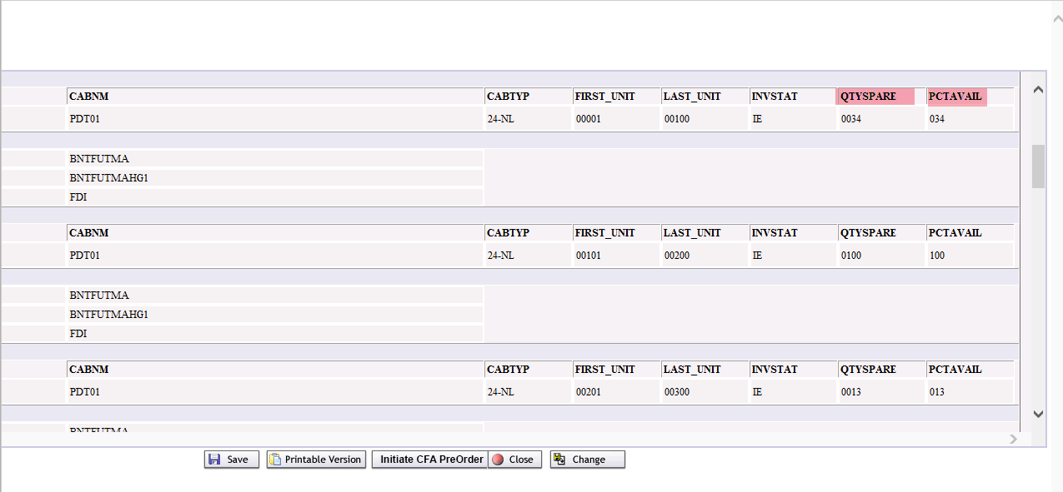

In this field … | EASE displays …
LOCA | Originating CLLI code entered
LOCZ | Terminating CLLI code entered
CABNM | Cable name—the identifier for a cable comprising several CFA groups
CABTYP | Type of facility—the cable type, gauge, load coil spacing, and load coil inductance
FIRST UNIT (also known as Channel) | Number of the first unit (also known as Channel) in a CFA group
In this field … | EASE displays …
LAST UNIT (also known as Channel) | Number of the last unit (also known as Channel) in a CFA group
INVSTAT | Inventory status—the status of the CFA group
QTYSPARE | Quantity spare—the number of CFA units available
PCTAVAIL | Percentage available—the percentage of CFA units available
- Select the radio button associated to the row of data you want to select and select Intiate CFA PreOrder.
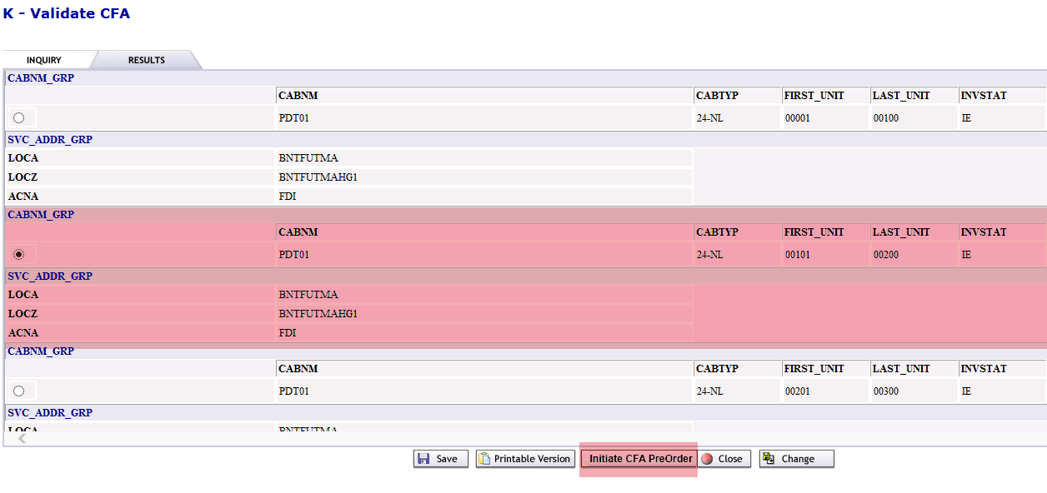

The facility information selected will automatically return the Validate CFA Inquiry screen with the original data entered in the ACNA, LOCA, and LOC Z fields and will auto populate the data from the row selected in the previous step to the following fields:
  - CABNM – The name of the cable.
  - FIRST UNIT – The number of the first unit (also known as Channel) in a CFA group.
  - LAST UNIT – The number of the last unit (also known as Channel) in a CFA group.
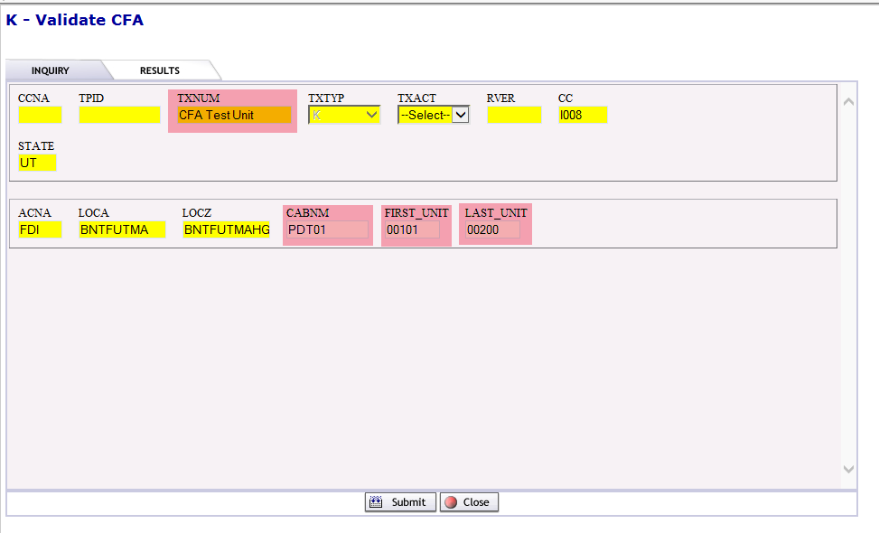
NOTE: A system generated TXNUM will be entered. The user can override this information with the PON to be used during ordering to better track their inquiries.
- Select Submit.

The UNIT or CHANNEL response data will display.
The selected cable information will be provided in the CFA UNITS RESP section.
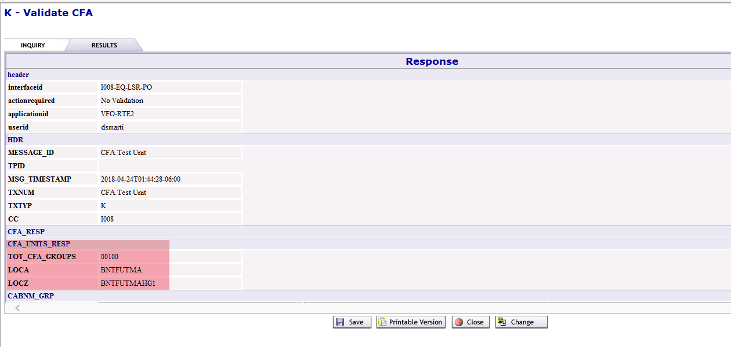
Each UNIT or CHANNEL of the selected facility will display with corresponding detail.
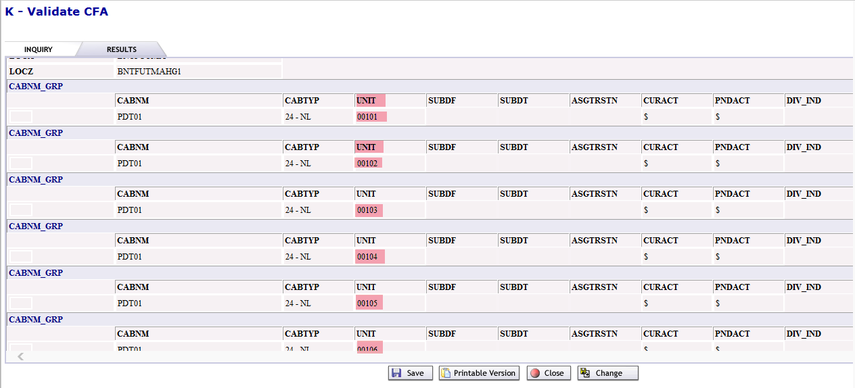

The Results output is extremely wide. Scroll to the right to see the remaining columns of data.
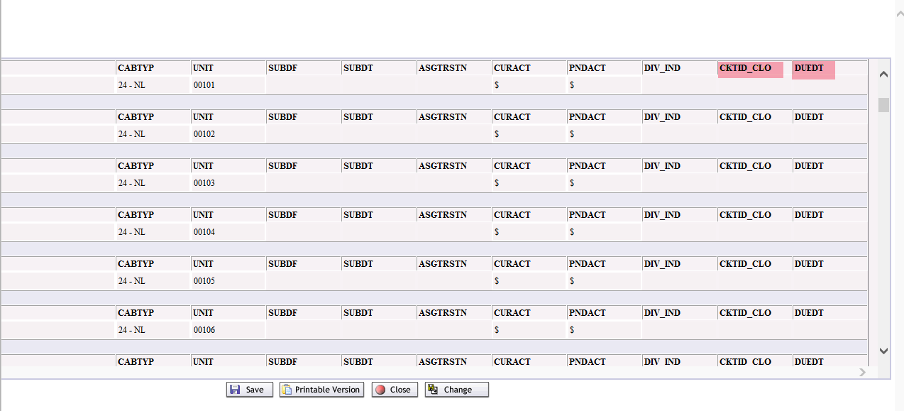
The CFA response provides the following detail:
- CABNM
- CABTYP
- UNIT (also known as Channel)
- LOCA
- LOCZ
- CURACT
- PNDACT
- CKTID/CLO
- DUEDT
In this field … | EASE displays …
CABNM | Cable name—the identifier for a cable comprising several CFA groups
CABTYP | Type of facility—the cable type, gauge, load coil spacing, and load coil inductance

In this field … | EASE displays …
UNIT (also known as Channel) | A specific unit (also known as Channel) in the cable identified by CABNM
LOCA | Originating CLLI code entered
LOCZ | Terminating CLLI code entered
CURACT | Current activity for the unit  $ = Spare  W = Working
PNDACT | Pending activity for the unit  $ = Spare  W = Working
CKTID/CLO | Circuit ID/circuit layout order number
DUEDT | Due date

Select Save/Printable Version/Close or Change.

Unit (also known as Channel) Response Cable Facility Query
If the entire cable facility data is known, it can all be entered as part of one query. The CFA Query can bypass the Groups detail if the initial query includes Unit information.

- Enter data for a Unit Response Cable Facility query:
  - ACNA – The Common Language code for your company.
  - LOCA – The originating CLLI code.
  - LOCZ – The terminating CLLI code.
  - CABNM – The name of the cable.
  - FIRST UNIT – The number of the first unit (also known as Channel) in a CFA group.
  - LAST UNIT – The number of the last unit (also known as Channel) in a CFA group.
- Submit.

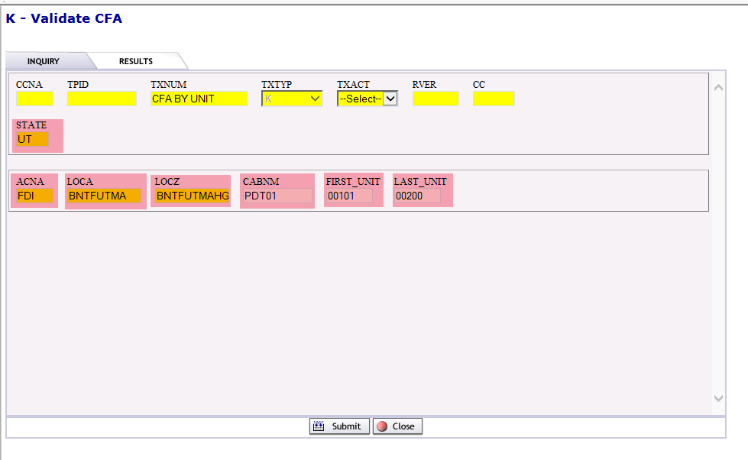

The CFA response provides the following detail:
- CABNM
- CABTYP
- UNIT (also known as Channel)
- LOCA
- LOCZ
- CURACT
- PNDACT
- CKTID/CLO
- DUEDT
The UNIT or CHANNEL response data will display.
The selected cable information will be provided in the CFA UNITS RESP section.

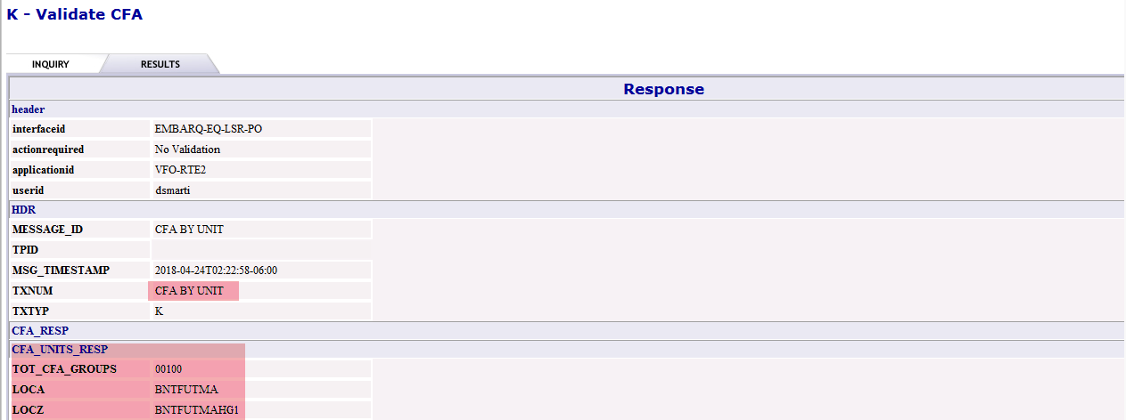

Each UNIT or CHANNEL of the selected facility will display with corresponding detail.

The Results output is extremely wide. Scroll to the right to see the remaining columns of data.

In this field … | EASE displays …
TOTAL CFA UNITS (also known as Channel) | Number of CFA units listed
CABTYP | Type of facility—the cable type, gauge, load coil spacing, and load coil inductance
UNIT (also known as Channel) | A specific unit (also known as Channel) in the cable identified by CABNM
LOCA | Originating CLLI code entered
LOCZ | Terminating CLLI code entered
CURACT | Current activity for the unit  $ = Spare  W = Working
PNDACT | Pending activity for the unit  $ = Spare  W = Working
CKTID/CLO | Circuit ID/circuit layout order number
DUEDT | Due date
Select Save/Printable Version/Close or Change.

Successful Responses
If a response is successful, RESPD and PRESPD messages are displayed in the GUI or returned via UOM/XML.

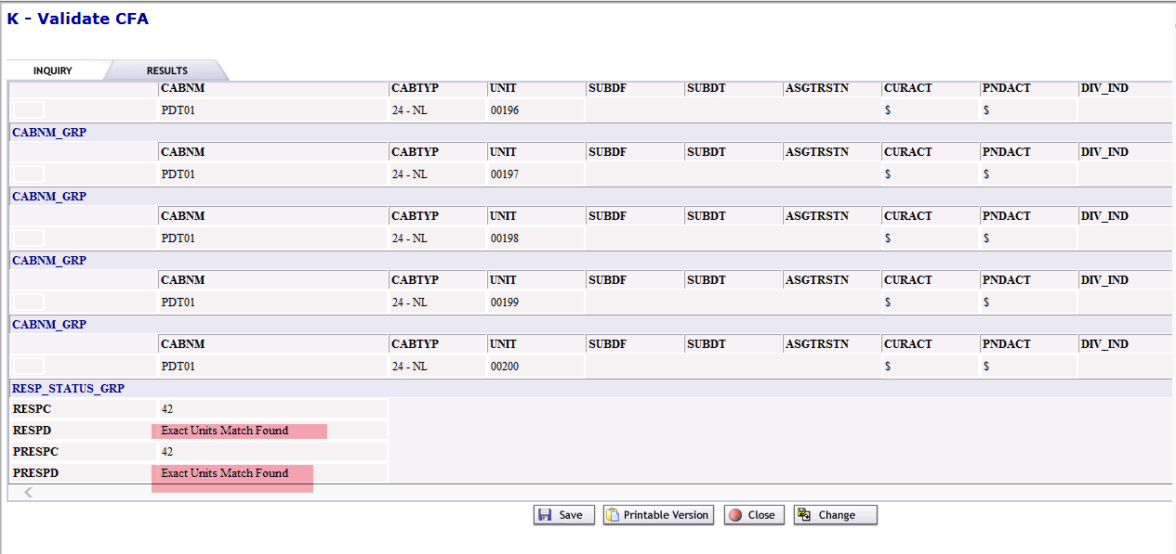

Unsuccessful Responses
If no CFA detail is available in TIRKS, an errror message is displayed in the GUI or returned via UOM/XML.
